



|  |  |  |
| --- | --- | --- |
| Aboriginal Torres Strait Island Flags | Aboriginal Torres Strait Island Flags |  |

Queensland Corrective Services

***Reframing the Relationship Plan 2024-2033***

**Proportionally, we are the most incarcerated people on the planet. We are not an innately criminal people. Our children are alienated from their families at unprecedented rates. This cannot be because we have no love for them. And our youth languish in detention in obscene numbers. They should be our hope for the future.**

**These dimensions of our crisis tell plainly the structural nature of our problem. This is *the torment of our powerlessness*.**

**The Uluru Statement from the Heart**

# Acknowledgement of Country

Queensland Corrective Services respectfully acknowledges and recognises First Nations peoples[1] as the Traditional Owners and Custodians of the lands, winds, and waters across Queensland where we live, learn and work.

We pay our respects and acknowledge the important role of Elders past and present, for they hold the memories of the traditions, cultures and aspirations of Australia’s First Nations peoples, and have taken on the responsibility to protect and promote their culture and leave a legacy for future Elders and leaders.

We promise to be respectful, take lead from the community and walk together with First Nations peoples, communities and organisations in our journey to better justice outcomes.

We recognise that First Nations cultures are rich and diverse and that we, as an agency, have a responsibility to facilitate efforts that account for this to ensure equity for all.

We celebrate First Nations histories, in particular the strength, resilience and courage that has occurred over time which inspires current and future generations of all Queenslanders to create a better Queensland.

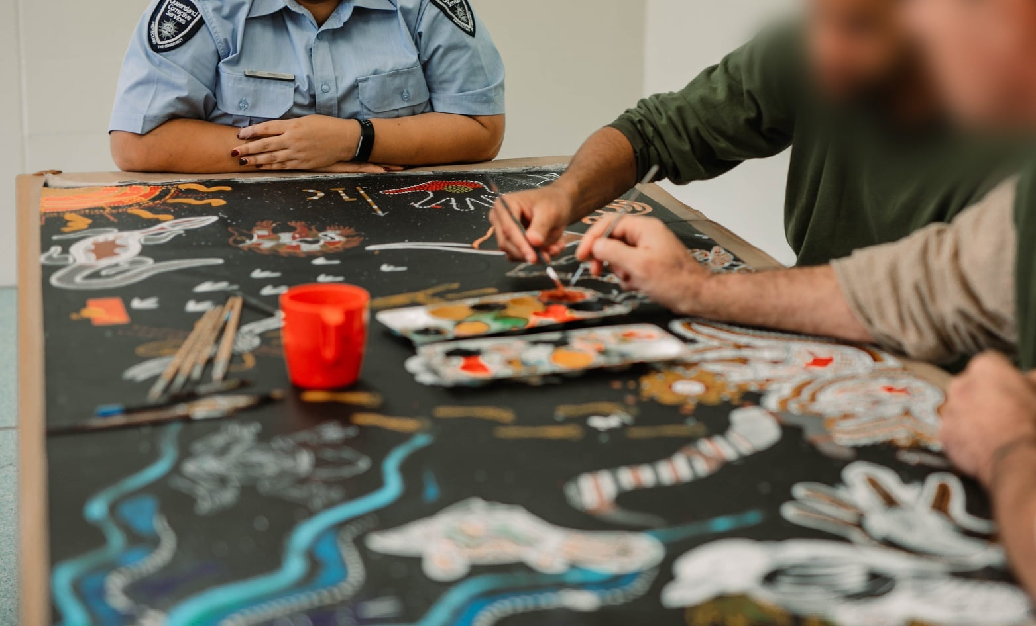

# Commissioner foreword

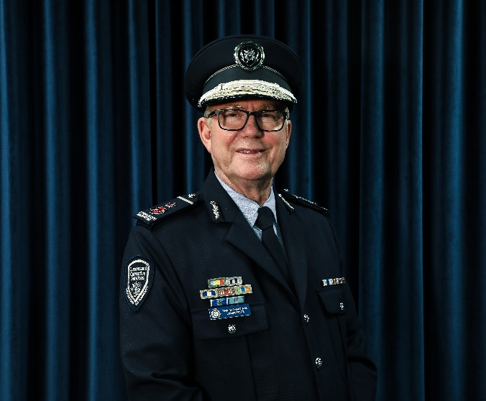Queensland Corrective Services recognises the high incarceration rate and over-representation of First Nations peoples in the correctional system, and we are committed to playing our part in addressing this.

We all have a role in working towards a future in which First Nations peoples prosper and the relationship between First Nations peoples and QCS is reframed—in the spirit of reconciliation and the Path to Treaty.

By transforming and enriching our approach to the humane containment, supervision and rehabilitation of offenders to ensure they are culturally appropriate, we have the power to realign our approaches to the benefit of all Queenslanders.

*Corrections 2030* recognises that the responsibility for reducing crime and incarceration rates rests with our whole community. It also recognises that, as a criminal justice system agency, we have an important role and responsibility to advance these objectives, through partnering and collaboration.

*The QCS Reframing the Relationship Plan 2024-2033* (the Plan) represents a beginning; with a particular focus, and commitment to action, to close the gap on First Nations peoples incarceration and victimisation from violence. It is by working in genuine partnership with First Nations people, families, and communities—enabling those with lived experience and whose communities and lives are most affected to lead—that we can improve outcomes.

This includes increasing opportunities for connection to culture and family, helping provide meaningful rehabilitation, and assisting successful returns to community. Under this Plan, we will accelerate crucially important shifts to ensure the responses we provide to First Nations peoples, families, and communities, are appropriate and central to the work we do.

The Plan’s development was informed by diverse voices of experience, literature, and data. I would like to thank the many highly-committed QCS staff and external service providers who provided key insights, guidance and significant leadership in the development of this Plan.

I would especially like to thank our First Nations staff, including Cultural Liaison Officers, the officers at the Murridhagun Cultural Centre, Community Justice Groups, Elders, local councils of First Nations communities, service providers, community-controlled organisations, academics, and prisoners and offenders who also shared their lived experience to inform this work.

Paul Stewart APM

Contents

Acknowledgement of Country 3

Commissioner foreword 4

The incarceration crisis 6

Overview and purpose 7

Our next steps 8

Context 10

Drivers of high incarceration rates 10

Higher rates of serious violent crime and intra-communal violence 10

Higher rates of chronic and harmful offending 12

Prevalence of risk, need and responsivity (RNR) factors 13

One-size fits-all approaches do not work 14

Impacts of the incarceration crisis 14

Our commitment to Closing the Gap 14

The way forward 16

Stop the cycle of violence 17

Partner and empower 20

Leverage connectedness 23

Elevate First Nations 26

Learn and improve 29

Performance indicators 31

Endnotes 32

# The incarceration crisis



**First Nations people in Queensland represent:**

|  |  |  |  |  |  |  |  |  |  |
| --- | --- | --- | --- | --- | --- | --- | --- | --- | --- |
| **The proportion of First Nations prisoners has steadily increased over the past 10 years and continues to grow.** | | | | | | | | | |
|  | **4.6% of the population[2]** |  |  | **28% of people under Community-based supervision[3]** |  | **37% of all prisoners[4]** |  |  | **45% of female prisoners.[5]** |



**Most First Nations peoples have never been imprisoned.** However, they have contact with the criminal justice system – as both offenders and victims – at much higher rates than non-Indigenous peoples.

**In Queensland**

|  |  |  |  |
| --- | --- | --- | --- |
|  | **of First Nations prisoners have been imprisoned more than once, compared to 61% of non-Indigenous prisoners.[6]** |  | **First Nations prisoners are roughly 50% more likely to return to custody and roughly 40% more likely to return to Community Corrections with a new order or sanction within two years of discharge, compared to non‑Indigenous prisoners.[7]** |
|  | **First Nations people are 12x more likely to be imprisoned[8] and 2x more likely to have parole suspended[9] compared to non-Indigenous people.** |  | **The QPC estimated that First Nations overrepresentation costs  around $272 million per year in imprisonment costs alone.[10]** |

First Nations peoples and the Queensland Government are building a reframed relationship that acknowledges, embraces and celebrates the humanity of First Nations peoples. Incarceration rates and the overrepresentation of First Nations peoples in the correctional system is one of Australia’s most pressing and longstanding problems—despite various efforts to reduce it.[11] The high human, economic and cultural costs associated with First Nations peoples’ overrepresentation must be reduced. To do so is in the best interests of communities throughout Queensland and of the individuals involved and is critical to a reframed relationship with First Nations peoples.

# Overview and purpose

Data speaks to the scale of the incarceration crisis. While Australia’s First Nations peoples are amongst the most incarcerated people in the world, incarceration rates also reflect geographical concentrations of offending in remote and highly socio-economically disadvantaged areas. The issue of overrepresentation is national and state-wide, with Queensland’s Far Northern and Northern regions amongst the epicentres of this crisis.

While data gives insight into the stark scale and severity of overrepresentation, it also alludes to the countless stories and experiences of the devastating impact of crime and violence on people’s lives and our communities. Unless decisive action is taken to turn around escalating incarceration rates, poor outcomes—including imprisonment—can be predicted to continue into the future.

In 2020, the Queensland Government reaffirmed its commitment to Closing the Gap by entering the National Agreement on Closing the Gap and its targets. First and foremost, this Plan is our commitment to action in response to the incarceration crisis and to Close the Gap as a cornerstone to a reframed relationship with First Nations peoples.

This Plan also expresses our commitment to broader reforms within Queensland to reframe the relationship with First Nations peoples through the Path to Treaty. Path to Treaty reinforces the imperative for us to engage in truth-telling about our shared histories and understand how past laws, policies and practices have, and continue to, impact First Nations peoples. It also highlights our need to come together as equals to write a new future together which promotes healing, justice, and reconciliation.

By getting this right for First Nations peoples, all Queenslanders benefit. Working in true partnership with First Nations peoples will strengthen QCS’ approaches for all offenders and will be for the betterment of all our communities.

In 2019, the Queensland Government released its Statement of Commitment to reframe the relationship between First Nations peoples and the Queensland Government. The Public Sector Act 2022 (the Act) acknowledges that public sector organisations have a unique role and obligation to reframe relationships, develop cultural capability and recognise the importance of self-determination for First Nations peoples. The Act describes our responsibilities by listing eight key role elements QCS must fulfil. This Plan is underpinned by our commitment to fulfilling these eight elements by:

* Recognising and honouring First Nations peoples as the first peoples of Queensland.
* Engaging in truth-telling about the shared history of all Australians.
* Recognising the importance to First Nations peoples of the right to self-determination.
* Promoting cultural safety and cultural capability at all levels of QCS.
* Working in partnership with First Nations peoples to actively promote, include and act in a way that aligns with their perspectives, in particular when making decisions directly affecting them.
* Ensuring the workforce and leadership of the entities are reflective of the community they serve, having regard to chapter 2 and chapter 3, part 3 of the Act.
* Promoting a fair and inclusive public sector that supports a sense of dignity and belonging for First Nations peoples.
* Supporting the aims, aspirations and employment needs of First Nations peoples and the need for their greater involvement in QCS.[12]

Each key strategic area for action in the Plan also aligns with one of the five QCS core principles set out in [*Corrections 2030*](https://www.publications.qld.gov.au/dataset/qcs-strategic-and-other-plans/resource/042e2161-a4e0-4d79-b26a-8f3fbdc0e613). Under each key strategic area:

* **long term outcomes** describe where we want to get to and what success looks like
* **new approaches required** highlight the major shifts to be made
* **short and medium term objectives** are outlined.

Our performance against this Plan will be audited annually so that we continue to regularly monitor our progress in supporting a reframed relationship.

## Our next steps

The next steps to reframing the relationship will be underpinned by the principle of self-determination actioned through truth telling, empowerment, agreement making and high expectations relationships.

With this in mind, QCS is committed to working collaboratively with First Nations peoples to co-design and implement reforms to facilitate local level decision-making and agreements to build a reframed relationship with First Nations people.

**Annual Action Plans** will support the Plan’s implementation, ensuring details of internal responsibilities are clear (to drive change) and our approaches remain responsive to learnings identified throughout the implementation of the Plan. Importantly, these annual Action Plans will report our implementation aligned to the eight components detailed within section 21(2) of the Act.

This will include extensive consultation with our staff in 2024 and beyond to inform and develop annual Action Plans.

**QCS Reframing the Relationship Plan 2024-2034**

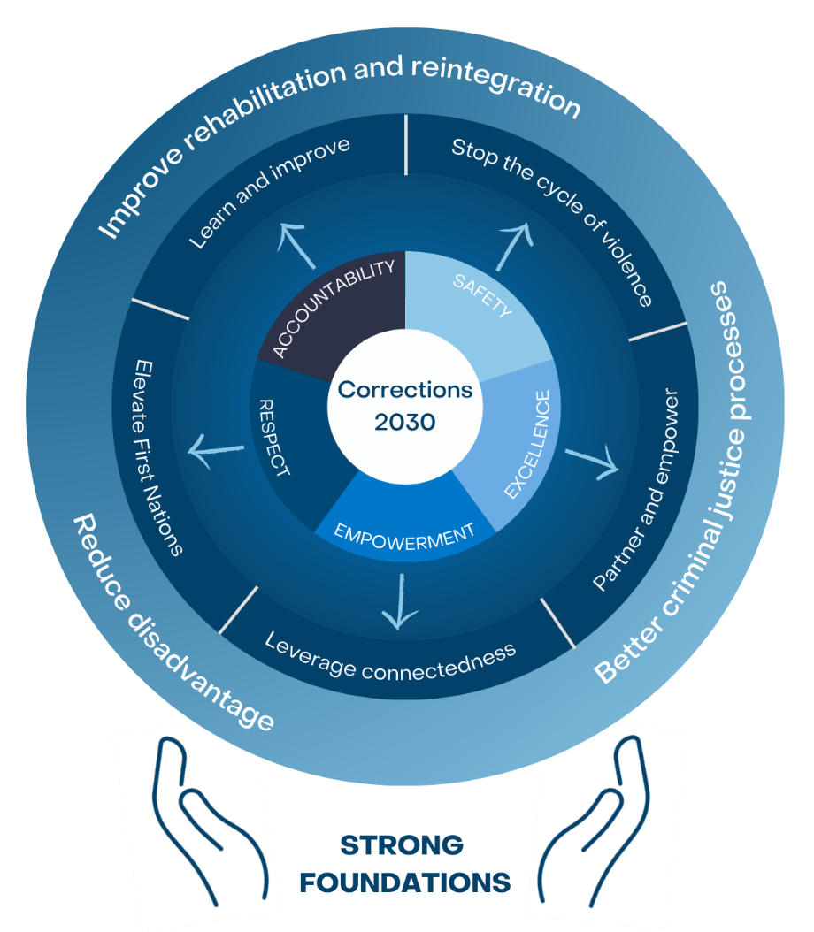

# Context

## DriveA picture containing screenshot, square, black Description automatically generatedrs of high incarceration rates

Imprisonment rates for both First Nations peoples and non-Indigenous peoples have been increasing for decades. Analysis suggests that changes within the criminal justice system are driving rising incarceration rates rather than increasing crime rates. This includes factors such as:

* people being more willing to report crime
* a greater policing effort and effectiveness
* a stronger propensity of police to use court action (rather than cautions or penalty notices)
* a higher willingness of courts to impose custodial sentences (rather than community-based orders)
* tighter bail laws and a higher recidivism rate.

Concurrently, imprisonment rates for First Nations peoples are higher, and have accelerated more quickly, than for the general population. This reflects the different offending profiles, level of exposure to socioeconomic determinants of incarceration and the disproportionate impact policy changes are having on First Nations peoples.[13]

### Higher rates of serious violent crime and intra-communal violence

The key proximate cause of overrepresentation in Queensland is higher rates of offending, including serious (and often violent) crime, particularly intra-communal violence.[14] QCS data presented in Figure 1 reflects this—more than half of First Nations peoples incarcerated have a violent non-sexual offence recorded as a most serious offence.

Figure 1. Most serious offences for sentenced First Nations prisoners, January 2013 – April 2023.

Source: QCS IOMS data.

Furthermore, QCS data presented in Figure 2 reflects that more than half of First Nations prisoners have a domestic and family violence related offence recorded and that this rate has steadily increased over time.

Figure 2. First Nations prisoners with a domestic violence related offence, January 2018 – April 2023.

Source: QCS IOMS data.

Moreover, as at 30 June 2023, approximately 83 percent of First Nations prisoners had at least one domestic and family violence warning flag[15] recorded and approximately 74 percent had a DV – Current warning flag—an indicator of intra-communal violence.[16]

Figure 3. First Nations prisoners with a domestic violence flag as at 30 June 2023.

Source: QCS IOMS data.

Intergenerational and cyclical family violence is prevalent in some First Nations communities and has been recognised as a key driver of the incarceration of First Nations men and, increasingly, women.[17] The disproportionate severity of violence is also highlighted by First Nations adults being 32 times more likely to be hospitalised for family violence compared with non-Indigenous adults in 2016–17.[18]

### Higher rates of chronic and harmful offending

Offending profiles of First Nations peoples and non-Indigenous peoples differ—contributing to higher imprisonment rates among First Nations peoples. In 2019, the Queensland Productivity Commission’s inquiry into imprisonment and recidivism concluded:

Aboriginal and Torres Strait Islander people are much more likely to offend, and much more likely to fall into more chronic and harmful offender groups. Similarly, men are more likely to offend, and more likely to exhibit chronic and harmful offending than women. The former effect tends to dominate the latter, and Indigenous women tend to exhibit behaviour which is much more similar to Indigenous men than to non-Indigenous women. Lastly, offending is more chronic and harmful among remote and regional populations of Aboriginal and Torres strait islander [sic] people than for their metropolitan equivalents.[19]

This does not mean First Nations peoples are innately more criminal than other Queenslanders. The prevalence of risk, need and responsivity **(RNR)** factors associated with incarceration within First Nations communities is a historically new phenomenon within one of the oldest continuing living cultures of the world.

### Prevalence of risk, need and responsivity (RNR) factors

**First Nations peoples heightened exposure to (and experience of) RNR factors**[20] **which are linked with offending is at the core of overrepresentation. The prevalence of RNR factors reflect entrenched socioeconomic disadvantage which is frequently most extreme in** remote and discrete communities.[21] A system of intersecting factors contribute to high rates of incarceration, including:

|  |
| --- |
| *…Griffith University's Criminology Institute found that around 60 per cent of all Indigenous prisoners had previously been subject to a child protection order, hospitalised for a mental health episode or both—for female Indigenous prisoners this number rises to 76 per cent.[22]* |

* limited education and high rates of unemployment
* exposure to alcohol abuse and other problematic substance abuse
* family dysfunction and intergenerational trauma
* health, disability, and mental health issues
* homelessness and inadequate housing
* early interactions with the youth justice and child protection systems.[23]

In some places, imprisonment has become normalised and acts to reinforce dysfunction and disempowerment, continuing the cycle of offending and imprisonment within communities and across generations.[24]

**The roots of many of these** RNR **factors lie in the** laws, policies and practices which adversely targeted and impacted First Nations peoples during Queensland’s recent colonial past and the subsequent discriminatory administration of First Nations people's affairs following the federation of Australia.[25]

Although individuals who commit crime must be held to account, the ongoing legacy of disempowerment and traumatisation of First Nations peoples **have** important implications for effectively responding to the incarceration crisis.

### One-size fits-all approaches do not work

Changes within the criminal justice system have driven increased rates of the incarceration for all Queenslanders. However, the pre-existing overrepresentation of First Nations peoples and prevalence of RNR factors mean changes within the criminal justice system are likely to disproportionately impact First Nations peoples.

*Irregular employment, previous convictions for often low-level offending, and a lack of secure accommodation can disadvantage some accused Aboriginal and Torres Strait Islander people when applying for bail. Furthermore, when bail is granted, cultural obligations to attend sorry business following a death in the family or community, or to take care of family may conflict with commonly issued bail conditions—such as curfews and exclusion orders—leading to breach of bail conditions, revocation of bail and subsequent* *imprisonment.[26]*

Accordingly, mainstream and one-size fits-all approaches can compound overrepresentation by not appropriately responding to the complex and specific contexts of First Nations peoples, particularly those in remote and discrete communities.[27]

## Impacts of the incarceration crisis

Unless action is taken to turn around escalating incarceration rates, disadvantage and poor outcomes—including a high future likelihood of imprisonment—can be predicted. The persistence of overrepresentation across time, and in some instances, the normalisation of imprisonment and offending, entrenches a cycle of violence, trauma, dysfunction, disadvantage, disempowerment and incarceration in communities and across generations. Crime, violence and offending has a devastating impact upon people’s lives and the social and economic wellbeing of our communities.

First Nations people's deaths in custody further highlights the extremity of poor outcomes related to incarceration. Between 1979-80 and 2021-22 there have been 84 First Nations deaths in Queensland’s prisons.[28] While nationally the rate of First Nations people's deaths in prison have steadily declined over the last few decades, coronial inquests into deaths in custody continue to highlight the need for ongoing improvements in the criminal justice system.

To achieve our purpose ‘[t]o provide safe, modern and responsive correctional services, which rehabilitate prisoners and offenders, and prevent crime, making Queensland safer’ and effectively respond to our strategic risks we must address the incarceration crisis.[29]

## Our commitment to Closing the Gap

The Queensland Government has committed to Closing the Gap ‘*to* *overcome the entrenched inequality faced by too many Aboriginal and Torres Strait Islander people so that their life outcomes are equal to all Australians.*’[30] QCS has a vital role if this objective is to be achieved and must take action to address First Nations peoples overrepresentation.

|  |
| --- |
| ***Outcome 10:*** *Aboriginal and Torres Strait Islander people are not overrepresented in the criminal justice system.*  ***Target 10:*** *By 2031, reduce the rate of Aboriginal and Torres Strait Islander adults held in incarceration by at least 15 per* *cent.*[31] |

QCS also has a fundamental responsibility to reduce all forms of family violence and abuse—acknowledging that intra-communal violence is closely associated with First Nations people's incarceration.

|  |
| --- |
| ***Outcome 13:*** *Aboriginal and Torres Strait Islander families and households are safe.*  ***Target 13:*** *By 2031, the rate of all forms of family violence and abuse against Aboriginal and Torres Strait Islander women and children is reduced at least by 50%, as progress towards* *zero.*[32] |

Figure 4 shows Australia’s, and Queensland’s, performance towards achieving at least a 15 per cent reduction in the rate of adult First Nations peoples incarcerated. As can be seen, the escalating overrepresentation of First Nations peoples must be substantially disrupted to meet the 2031 Closing the Gap target.

Figure 4. Imprisonment rate compared with Closing the Gap targets. Data source: Australian Productivity Commission, [Closing the Gap Information Repository](https://www.pc.gov.au/closing-the-gap-data/dashboard/socioeconomic/outcome-area10), retrieved 27 June 2023.

There is much that QCS can do to reduce First Nations people's incarceration rates and achieve Closing the Gap targets. QCS must build strong foundations and take steps to address the three key action areas which will reduce First Nations people's incarceration.[33]

# The way forward

The Plan has been developed to ensure we are doing all we can and are working through empowering partnerships with First Nations peoples.

As a matter of priority QCS must build strong foundations to enable action under the Plan. QCS also has a primary role in improving the rehabilitation and reintegration of those in the correctional system so that First Nations peoples are less likely to return to offending. QCS alone cannot reduce First Nations people's incarceration—we have an important contribution to make to improve criminal justice processes as a key agency within the criminal justice system.

Effective action to reduce First Nations people's disadvantage is likely to have the greatest long-term impact on reducing overrepresentation. While QCS does not have a primary role in reducing general disadvantage we do have an important responsibility not to compound or reinforce it. We also have a critical contribution to make in addressing risk factors associated with offending and partnering with others to reduce the disadvantage of First Nations peoples in contact with the correctional system.

Violence, including domestic and family violence, is a pervasive driver of imprisonment and must be effectively addressed to reduce the incarceration of First Nations peoples. This was a key theme during stakeholder consultation and is also highlighted by the data detailed earlier.

***1. Safety – Promote safety***

# Stop the cycle of violence

It is our job to hold people in our custody, care and supervision to account for violent offending. We also have a responsibility to role model and promote pro-social behaviour and attitudes that supports individuals and communities to challenge violence behaviour.

We must do all we can to help stop the cycle of violence. Violent behaviours and norms in the community spill into, and may be further exacerbated by, the correctional environment. Many prisoners eventually return to their communities and remain at risk of repeating this cycle.

More effective responses to violence are required to address the key proximate cause of overrepresentation and high incarceration rates in Queensland. This will improve the safety and wellbeing of First Nations offenders, their families, communities, our staff and Queenslanders generally.

 To stop the cycle of violence a suite of mutually reinforcing actions is needed, including ‘inside outside’ approaches which begin in custody and continue in the community.

***The level of violence leading to incarceration is alarming for our Aboriginal and Torres Strait Islander communities. This must be tackled to turn the tide on Indigenous incarceration.***

- First Nations QCS Officer

***We just don’t have a strong enough focus on addressing violence, including domestic and family violence.***

***How do we not have a culturally appropriate program in here for family violence and gendered violence?***

***We need to tackle generalised norms around this stuff too.***

- Custodial Officer

|  |
| --- |
| ***A former* … *police officer observed that some of the men returning from prison are important ‘power players’ in the community, with considerable influence over family members and over inter-family conflict. He suggested these individuals could have a significant impact if they were enlisted to help with reintegration.***xxiv |

**Long term outcomes**

***I had a guy the other day, it’s his fifth time here and he’s never done a program.***

***He said he was scared he was going to kill his partner.***

***I’m scared he’s going to kill his partner too.***

- Custodial Officer

***We’d love to get into the prisons and really talk to the guys and the women to design approaches that are evidence informed and culturally sensitive, so they are really meaningful for them.***

- First Nations Community Organisation

* The intergenerational cycle of violence, trauma, and incarceration is broken.

Greater harmony in families and communities, including within correctional facilities, with positive impacts for safety and wellbeing.

**New approaches required**

* Recognise and target service delivery to reflect that violence, including intra-communal and domestic and family violence, is the leading proximate cause of First Nations people's incarceration. This includes co-designing new responses which effectively address violence.
* QCS’ service delivery and rehabilitation approaches are, by default, designed and delivered to be meaningful, appropriate, and effective for First Nations peoples.
* QCS goes beyond the individual and develops holistic inside-outside approaches which work with partners, families and communities to stop the cycle of violence in ways that reduce harms for victim-survivors and reduces the rate of people entering the criminal justice system.
* Effective methods are implemented to address underlying risk factors associated with violent offending, e.g. drug and alcohol use, financial stress, brain health, mental health, and a focus on trauma informed practice.
* QCS proactively seeks opportunities to help stop the cycle of violence, including through the lens of improving wellbeing and positive relationships to promote non-violent behaviours, positive conflict resolution, relationships, and communication.

***On violence, you can do things in your talking points with the guys in your everyday conversations. If you have time, you can have important natural conversations, including about healthy relationships.***

- Cultural Liaison Officer

**Example of Excellence**

The Sexual Offending Program for Indigenous Males (SOPIM) re-design prioritised First Nations involvement, including in design and delivery. The replacement Strong Solid Spirit Program (SSS) is delivered in partnership with First Nations program officers to enhance cultural responsiveness and safety.

**Short and medium term objectives**

***Short term***

* Engage with our staff to identify what works, what QCS can improve or develop to ensure First Nations staff feel culturally safe.
* Co-design new programs and reinforce existing approaches for First Nations people in our care to tackle violence in correctional environments and effectively prevent further transmission of violence in the community.
* Promote positive relationships and communication, including by training prisoners, offenders, and staff alike in de-escalation strategies, role modelling non-violent conflict resolution strategies, and healthy relationships.
* Recognise and reward staff and offenders who excel in terms of de-escalation, positive communication, and role modelling.
* Bolster public education/social messaging campaigns within correctional environments and in communities to establish norms that prevent violence.
* Implement end-to-end case management methods which are responsive to inside-outside approaches.
* Embed trauma informed practice and training for frontline staff.

***Medium term***

* Harness and build the capability of those with lived experience who have turned their lives around to play a role in acting as credible messengers to help stop the transmission of violence, change norms and lead positive change.
* Partner and provide additional support needed to break the cycle, including through services and approaches targeting prisoners and offenders, their children and families.
* Develop and implement strategies which are responsive to reducing First Nations people's disadvantage and risk factors associated with violent offending, such as domestic and family violence, mental health, disability and substance misuse.

***No contact DV orders just don’t work for our people in small communities. I can’t see how they lead to success. They set people up for failure and re-imprisonment by excluding them from their own family and community.***

***We work with the men to build their understanding, but we need to be working with and educating their women too.***

***The system needs to deal with reality. Instead of no contact orders, some people want extra support like Relationships Australia checking in after release with the couple. This could help the man and the woman to nip any trouble and stress in the bud if they want a long-term relationship.***

- Cultural Liaison Officer

***The Positive Futures program put a few more tools in my basket that helps me with my understanding and how to go about things when I'm in hot water. It's a bit more open down there, being in a cultural environment and just being free to let your guard down — it's cultural healing.***

- former prisoner on QCS Positive Futures program delivered by Community Corrections after release from prison for domestic violence offences

Building on our internal and external partnerships are critical. Accelerating progress to Close the Gap means First Nations peoples must be enabled and empowered to take a leading role in bringing about positive change for their own peoples and communities. This is true in corrections, as it is across government and is recognised as a key principle within legislation governing the public service in Queensland.[34] We must also partner to develop better criminal justice processes, reduce agency and service silos and support people-centred approaches to meaningfully reduce First Nations people's disadvantage.

***2. Excellence – Strengthen partnering and collaboration***

# Partner and empower

Through partnerships, QCS must increasingly support First Nations ownership, engagement, and oversight of solutions to address First Nations peoples offending—including in program design, governance, implementation, and evaluation. A genuine partnership with First Nations peoples to solve the problem of overrepresentation means that unique First Nations peoples perspectives, experiences, cultures, and identities can inform, strengthen, enrich and transform our approaches for all people.

There are many opportunities for QCS to strengthen longstanding and new external partnerships, such as with Community Justice Groups, Elders and Respected Persons, First Nations leaders and organisations to enable First Nations-led and locally owned rehabilitation and reintegration efforts. QCS must be an active and enabling partner, including to facilitate expertise, skills, data and information as required to support effective partnerships and shared decision making. Building strong partnerships in those geographic areas which are most overrepresented in the correctional system is also vital to success.

|  |
| --- |
| ***… involvement of community members is a key success factor in successful reintegration*** ***programs.***[35] |

***We have some great Community Justice Group partnerships. They’re such an important piece of the puzzle, including because they have that cultural authority. We could work with them more to help plan for offenders coming back into community.***

- Community Corrections officer

***QCS needs to work more with First Nations people and organisations to make sure programs offered are culturally appropriate.***

- Community member

**Long term outcomes**

***It would be great to have more of our own community organisations coming into the centres, and then supporting people when they are going out too.***

- Cultural Liaison Officer

* QCS is leading Australian corrections in terms of our genuine First Nations partnerships and shared decision-making approaches.
* Agency and service silos are gone, and people are at the centre of effective, integrated end-to-end approaches to rehabilitation and reintegration.
* Services are highly accountable to the communities they are funded to serve.

**New approaches required**

* First Nations peoples and communities are involved in the design and delivery of all relevant projects and programs in QCS, including through co-design.
* Increase access to community services and approaches that are designed and delivered to meet the needs of First Nations peoples.
* Increase partnering with government services, First Nations organisations and culturally sensitive mainstream services to, for example:
  + increase access to, and reduce breaches of, bail and parole
  + improve case management, referrals, and service support
  + reduce First Nations people's disadvantage.

**Opportunities for QCS to contribute to reducing disadvantage**

|  |  |  |  |
| --- | --- | --- | --- |
| Right And Left Brain outline | Identify and support those living with mental ill health and cognitive impairment, such as acquired brain injuries and foetal alcohol spectrum disorder. | Medicine outline | Enhance alcohol and other drugs rehabilitation and counselling. |
| Books outline | Build fundamental capabilities (e.g. financial literacy, access to identification, job readiness skills). | Construction worker male outline | Expand opportunities for vocational training and skills development, employment and the provision of employment pathways. |

**Short- and medium-term objectives**

***Short term***

* Embed First Nations people's participation and representation in QCS governance systems, including ensuring community involvement in program/project governance.
* Engage with our First Nations staff to ensure QCS Implement opportunities to partner with First Nations peoples, organisations and communities based on mutual areas of focus, need, and readiness, including strengthening partnerships with:
  + Community Justice Groups, Murri Court and other leadership groups including local councils

**Example of Excellence**

The ‘Brother Brother’ Program at Brisbane Correctional Centre is provided in partnership with Gallang Place to give First Nations prisoners a culturally appropriate cell visitation and listening service.

* + First Nations people's community-controlled services.
* Explore options for community-led administration of sentences, such as community service.
* Apply the lessons learnt from Queensland’s From Jail to Jobs pilot and renew the focus on employment outcomes for First Nations peoples as an effective way to reduce reoffending.

***Medium term***

* Develop new models of working effectively with First Nations service providers, including within QCS procurement and contracting.
* Hold mainstream service providers accountable for their cultural capability to support the implementation of this Plan.
* Enhance QCS’ partnerships with Elders and Respected Persons and other grassroots groups, including appropriately supporting and resourcing these partnerships.
* Work in partnership to increase access to, and reduce breaches of, bail and parole.
* Mitigate specific recidivism risks in correctional facilities and the community through timely, continuous and well-coordinated care and support from trusted case workers, service supports and community agencies.
* Work in partnership to improve responses to disadvantage, especially factors associated with offending, such as substance use, the appropriate identification and response to neurological conditions and mental health issues.
* Work in partnership to improve access to quality education, vocational training and job skills, traineeships and increase employer partnerships, including with First Nations employers, to provide employment pathways for offenders.
* Undertake truth telling processes to be able to enter treaty, or treaties, in alignment with whole-of-government steps towards the Path to Treaty.

***The* [Elder] *visits really help the guys, you can really see the positive impact on their behaviour and outlook.***

- Custodial Officer

***Who is funded for what, and are they really delivering? These services are meant to be there to support our people, but they’re not accountable to us and sometimes it seems there’s no one there to provide the support that’s needed.***

- Community member

he well-established Aboriginal and Torres Strait Islander Social and Emotional Wellbeing model explains that social and emotional wellbeing of First Nations peoples is shaped by connections to body, mind and emotions, family and kinship, community, culture, Country, and spirit, spirituality and ancestors (see Figure 4).[36]

***3. Empowerment – Reduce crime***

# Leverage connectedness

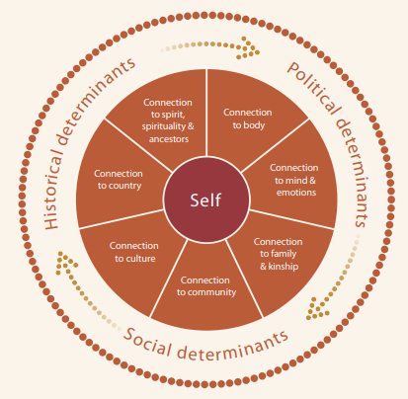People may experience healthy connections and resilience in some domains, while experiencing difficulty or the need for healing in others. For many First Nations peoples some connections have been significantly disrupted, including because of past government policies.

Restoring or strengthening connection, including connection to culture,[37] and family and community,[38] is associated with increased social and emotional wellbeing. These are well-established best practice features of First Nations rehabilitation and reintegration programs known to have positive impacts on reducing reoffending.[39]

By applying the Aboriginal and Torres Strait Islander Social and Emotional Wellbeing model, QCS can increasingly take a strengths-based approach to reducing First Nations peoples offending.

Figure 4. Model of Social and Emotional Wellbeing.

Gee, Dudgeon, Schultz, Hart and Kelly, 2013

**Long term outcomes**

* The corrections system taps into, and empowers, First Nations connectedness and provides a service which enables and supports healing and healthy connections across all domains of the Aboriginal and Torres Strait Islander Social and Emotional Wellbeing model.
* First Nations healing through connectedness is integrated into rehabilitation and reintegration approaches.
* A stronger, more effective, and humanising correctional system.

***Aboriginal people have our own spiritual beliefs and religion, and we have our own healers and medicine men and women. Why aren’t they recognised and afforded the same status as other religions through the Chaplains program in the prisons?***

- Community member

***We’ve got to have approaches that work with the partners, families and community too to prepare for reintegration.***

- Cultural Liaison Officer

***Getting people out on Country as soon as they are out of the centre can really have a positive impact. When people are determined to make a positive change, that on Country healing is really important.***

***-*** Community Corrections Officer

***I would love to engage more with the community. We absolutely need to be doing that. But for me to do that now, something else has got to go.***

- Cultural Liaison Officer

**New approaches required**

* Restore or strengthen connection to enhance social and emotional wellbeing of First Nations peoples to reduce disadvantage and recidivism.
* Involving family and friends early in reintegration planning and other support.
* Increasing opportunities for connection to culture, spirit, Country, and kin.

**Short- and medium-term objectives**

***Short term***

* Enhance and expand opportunities for offenders to connect to culture, spirit, Country, and kin, such as through art, dance, music and storytelling.
* Reduce barriers to visits and connections with family and the community.
* Promote family reconciliation, including through family engagement, parenting skills programs, family days, and where appropriate for those post-release, through supported transitions and home visits.
* Work in partnership with family and friends in reintegration planning (e.g. to assist with the implementation of practical strategies to manage risky behaviours and relationships, substance abuse and other triggers, or activities which keep individuals meaningfully engaged and connected).
* Facilitate reconnection through the promotion of, and access to, services which support reunification and connection, including Link-Up (Qld).

***It would be great if we could work more with Link Up while people are in the centre to help people re-connect.***

***-*** Cultural Liaison Officer

* Expand and strengthen the use of cultural connection plans and programs, such as those implemented as part of the Aurukun Justice Reintegration Project.

***Medium term***

* Pilot the use of a community reintegration support team of local community members in a high crime and high recidivism area, working with the Community Justice Group to support returning prisoners under the co-supervision of QCS.
* Implement culturally appropriate and responsive assessment processes and management practices through the integration of the Aboriginal and Torres Strait Islander Social and Emotional Wellbeing model and the Leading healing our way – Queensland Aboriginal and Torres Strait Islander Healing Strategy 2020-2040.

**Examples of Excellence**

***Cultural Connection Program***

The Cultural Connection Program at Lotus Glen Correctional Centre is provided in partnership with Apunipima Cape York Health Council. The program is open to participants from Aurukun and is a psychoeducational desistance program focusing on wellbeing, relationships, mental health, substance misuse, reconnecting with the community and awareness of and how to access community support services. The program offers continued support upon release either to a community-based order or liberty.

***Virtual visits***

Virtual visits have increased accessibility and affordability of visits for family and community members who live far away.

***We need more approaches that are culturally meaningful for Aboriginal and Torres Strait Islander people.***

***The right connection with other First Nations people is so powerful, you can see it.***

- Custodial Officer

Elevating our internal focus on First Nations to a central position, will reflect the scale of the incarceration crisis. Developing strong foundations to enable the delivery of responsive, capable, and culturally competent correctional services is a core QCS responsibility and is necessary to Close the Gap on First Nations people's incarceration. While QCS has established the Murridhagun Cultural Centre as a centre of cultural excellence, we must embed cultural excellence throughout our agency.

***4. Respect – Empower a professional workforce***

# Elevate First Nations

First Nations staff in QCS have an important role in helping elevate our First Nations focus. Increasing the number and proportion of First Nations staff in all positions, and at all levels, is a key QCS objective. To achieve this goal, our systems must continue to adapt to ensure First Nations staff are appropriately supported to succeed, including by enhancing our support for Cultural Liaison Officers.

Cultural Liaison Officers play a unique and valuable role. They bring vital knowledge and experience, and extensive networks and relationships in First Nations communities, which is critical to success. They also play a key role in managing and responding to the risk of self-harm, suicide and dealing with Sorry Business[40] impacting on First Nations peoples in our care and under our supervision.

QCS must also continue to build the cultural capability of our non-Indigenous staff, including through learning and better understandings of First Nations people's experiences, histories and cultures. This will give us a strong foundation to provide culturally appropriate and responsive corrective services and develop better criminal justice processes.

QCS is committed to treating all those in our care and under our supervision with respect. Demonstrating our embrace of First Nations peoples, cultures, histories, languages, and identities throughout all aspects of QCS’ operations will lead to better outcomes by enabling better informed decision-making and approaches.

**Example of Excellence**

The Murridhagun Cultural Centre provides support for matters designed to address the needs of First Nations staff, prisoners, offenders and victims, and provides Aboriginal and Torres Strait Islander Mental Health First Aid training and Cultural Responsiveness training.

**Long term outcomes**

* Our First Nations focus is integrated throughout all the work we do and strengthens corrective services approaches for all.
* QCS is an employer of choice for First Nations peoples.
* All QCS staff, including senior leadership, are culturally skilled and responsive.

**New approaches required**

***We need to empower our Cultural Liaison Officers and really support them to achieve the full potential of these important roles.***

- Community Corrections Officer

* QCS staffing structures, training, and internal budgets are appropriately resourced to enable a First Nations focus to be integrated throughout the organisation.
* QCS approaches are specifically designed to improve First Nations people's recruitment and retention, including appropriate professional development, career progression and mentoring opportunities.
* Elevate the importance of, and increase investment in, non-Indigenous staff cultural capability development, including through face-to-face training opportunities and experiential approaches wherever possible.

**Short- and medium-term objectives**

***Short term***

* Implement and appropriately resource a Chief Superintendent, First Nations and Cultural Capability position to drive reforms to maximise positive outcomes for First Nations peoples and assist the Commissioner and Deputy Commissioners to implement shared responsibility across the Executive Leadership Team for delivering the actions and outcomes identified in the Plan and its subsequent action plans.

***To turn the situation around on Indigenous incarceration it has to be a leading priority across the agency at all times. We have to have a bigger focus on this, or the situation will just continue to get worse.***

- Custodial Officer

* Review staffing structures, training, and internal budgets to ensure they support the changes needed to elevate QCS’ First Nations focus so it is central, including enhancing the role of the Murridhagun Cultural Centre and internal First Nations people's governance mechanisms (e.g. representative advisory groups/committees).
* Implement communications strategies and actions to raise the First Nations profile within QCS and enhance our culturally safe and respectful workplaces, including by promoting the voices of First Nations peoples and expanded use of First Nations visual signifiers (e.g. corporate artwork and uniforms).
* Actively promote and participate in key First Nations events (e.g. National Reconciliation Week, NAIDOC, Mabo Day, Cairns Indigenous Arts Fair, Laura Quinkan Indigenous Dance Festival, and the Coming of the Light in the Torres Strait Islands).
* Trial, evaluate and implement tailored approaches to increase recruitment and retention of First Nations staff (e.g. block First Nations intakes, preparatory programs, First Nations gap year/graduate programs, cadetships).
* Align, harmonise, and implement QCS Equity and Diversity Plan and Reconciliation Action Plan to this Plan.

***Medium term***

* Dedicated and proportionate internal budgeting for frontline and business support functions which enable a Frist Nations focus.
* Recruit for competency in working with First Nations peoples in key roles.
* Provide mandatory cultural training for all staff and regular opportunities for further upskilling.
* Embed a First Nations focus within organisational planning, performance, and management frameworks and mechanisms which drive our strategic and operational direction and focus.

***NAIDOC week is very good... But really this approach should be all year round because we have so many Indigenous prisoners here—not just for one week.***

- Correctional Officer

***When it comes to life expectancy for Indigenous people, we are living and breathing those statistics every week. It can take a toll.***

- Cultural Liaison Officer

***We don’t want to do things in a tokenistic way, and we don’t want to offend anyone, so sometimes we end up doing nothing.***

- Custodial Officer

There are no one-size fits-all approaches which can remain responsive to the complexity and vast array of First Nations people's lives, communities, cultures, and the partnerships needed to address the incarceration crisis. Place-based innovation and knowledge is required—facilitated through a strong foundation of ongoing learning to develop better criminal justice processes.

***5.Accountability – Drive innovation***

# Learn and improve

QCS must support local place-based innovations and approaches. This requires QCS to build a strong foundation which is informed by a nuanced understanding of offending patterns, recidivism and RNR factors for First Nations peoples (by regions and centres) so the right approaches can be taken in each different context. QCS will encourage and support a flexible learning-as-we-go approach.

QCS must also drive, monitor, and measure objective and evidence-based assessments of our progress toward Closing the Gap by building an evolving evidence base through research and incremental evaluation. We will support increased accountability and drive innovation through an improved understanding of First Nations, gender and geographically informed indicators to better understand, target, implement and learn from successful place-based innovation and new approaches.

We must also seize, and pursue, opportunities to enable learning, to improve practice, to pool data, different perspectives, ideas and knowledge to identity new opportunities and solutions.

**Long term outcomes**

***We need to build the evidence, but we also have to innovate and keep trying new things.***

***-*** Community Corrections Officer

* QCS has strong foundations underpinned by continuous learning which enable a high level of accountability and responsiveness to First Nations peoples in our care and under our supervision, their families, and the community.

***We have to be brave enough as an agency to step into this arena and do things differently. We need new approaches.***

- Corrections Officer, Specialist Operations

* QCS is an innovation leader and routinely implements effective place-based approaches which are responsive to First Nations peoples varying and complex contexts.

***Evidence is important but it is not the be all and end all for First Nations. We need the cultural side too as well as drawing on the therapeutic and clinical evidence side.***

- Cultural Liaison Officer

**New approaches required**

***Corrections has got to be accountable to First Nations people. Everyone one of us is impacted by the Indigenous imprisonment crisis in one way or another. The numbers mean there is no one that doesn’t have a direct connection to people and family who’ve been through the corrections system.***

- Community member

***We need to develop trust with First Nations people and communities, and this means being open and accountable and accepting no one really has all the answers to fix this, or it would fixed. We have to work it out together.***

- Corrections Officer, Organisational Capability

* Objective, evidence-based, flexible, timely and straightforward ways to identify, implement, measure and monitor progress to address the incarceration crisis and reduce First Nations people's disadvantage, improve rehabilitation and reintegration, develop better criminal justice processes and strong foundations.
* Evidence and place-based approaches informed by First Nations peoples are integrated into our business-as-usual.

**Short- and medium-term objectives**

***Short term***

* Conduct periodic First Nations themed Operational Performance Reviews, including involvement of key First Nations external partners.
* Establish QCS governance groups, and enhance existing arrangements, to improve accountability and oversight of key metrics relating to the overrepresentation of First Nations peoples and to drive change and innovation.
* Implement tools which enable QCS to meaningfully measure and track our performance in addressing the drivers of high incarceration rates, including QCS’ implementation of this Plan.
* Conduct research into, and review, QCS processes, and relevant criminal justice processes, contributing to incarceration.
* Research and evaluate the drivers of First Nations parolees returning to custody and partner with the Parole Board Queensland and other relevant agencies to implement solutions to improve parole and bail outcomes.

***Each community is so different and they need different approaches. The people of that community are in it for the long haul and that’s why they have to carry the thread over time and be able to lead and to learn. The reality is even the best intentioned outsiders move on, so communities get frustrated at the constant reinventing of the wheel.***

- Corrections Officer

Establish and sustain peer-led and locally focused, on-the-ground support mechanisms which encourage staff innovation and learning (e.g. Communities of Practice, First Nations Working Groups).

***Medium term***

* Participate in the Truth Telling and Healing Inquiry and integrate truth telling within business-as-usual to enable continuous learning and inform effective place-based approaches.

# Performance indicators



|  |  |  |  |  |
| --- | --- | --- | --- | --- |
| **Headline indicators** | | | | |
| Incarceration rate of First Nations peoples and the rate of all forms of family violence and abuse against First Nations peoples | | | | |
| **Other leading indicators** | | | | |
| **Stop the cycle of violence** | **Partner and empower** | **Leverage connectedness** | **Elevate First Nations** | **Learn and improve** |
| Violent offences and domestic and family violence flags  Preventable deaths in custody  Safer correctional centres – assaults  Number of registrations with QCS Victims Register | Community-controlled organisation partnerships relating to in-prison and post-release re-entry support  Procurement with First Nations businesses to be 3% of the value of QCS procurement contracts as per the *Queensland Indigenous (Aboriginal and Torres Strait Islander) Procurement Policy*.  Employer partnerships, including First Nations employers  First Nations traineeships and employment post-release | Self-harm and attempted suicide  Recidivism rates  Overrepresentation rates  First Nations rehabilitation and reintegration programs – co-designed with First Nations peoples | Proportion, retention, progression, and seniority of First Nations staff  First Nations staff engagement (Working for Queensland survey measure)  Proportion and retention of First Nations staff across QCS | First Nations themed OPRs conducted  Research and evaluation with a First Nations focus on outcomes  Enhanced accountability, governance and reporting on key metrics relating to First Nations people's overrepresentation. |

# Endnotes

1. The term ‘First Nations peoples’ is used throughout this document to refer to Aboriginal peoples and Torres Strait Islander peoples.
2. Australian Bureau of Statistics, 2022, [*Queensland: Aboriginal and Torres Strait Islander population summary*](https://www.abs.gov.au/articles/queensland-aboriginal-and-torres-strait-islander-population-summary#:~:text=In%20Queensland%20237%2C000%20people%20identified,%2C%20and%203.6%25%20in%202011.) retrieved on 11 July 2023.
3. QCS data, as at end of July 2022.
4. QCS data, as at end of April 2023.
5. QCS data, as at end of April 2023.
6. Australian Bureau of Statistics, 2022, [*Prisoners in Australia*](https://www.abs.gov.au/statistics/people/crime-and-justice/prisoners-australia/2022) retrieved on 11 July 2023.
7. QCS data, as at end of July 2022.
8. Australian Bureau of Statistics, 2022, [*Prisoners in Australia*](https://www.abs.gov.au/statistics/people/crime-and-justice/prisoners-australia/2022) retrieved on 11 July 2023.
9. QCS data, as at end April of 2022.
10. Queensland Productivity Commission, 2019, *Final Report Inquiry into Imprisonment and Recidivism*, page 405.
11. A long line of reports explore the profoundly troubling rate of First Nations peoples incarceration in Australia and have proposed strategies to reduce it, from the *Royal Commission into Aboriginal Death in Custody* which commenced in the 1980s, to the Queensland Productivity Commission’s *Final Report: Inquiry into Imprisonment and Recidivism* in 2019.
12. Adapted from the *Public Sector Act 2022 section 21(2)*.
13. The Queensland Productivity Commission’s (2019) *Final Report: Inquiry into Imprisonment and Recidivism* Chapter 4 provides a detailed analysis of the significant contributors to the increase in imprisonment in Queensland. Chapter 21 provides a detailed analysis of the primary causal factors for First Nations peoples high incarceration rate.
14. Don Weatherburn and Jessie Holmes, 2010, *Re-thinking Indigenous over-representation in prison*, Australian Journal of Social Issues, Vol. 45, No. 4, page 569.
15. A DV – Current or DV – History warning flag is activated on IOMS by QCS dependent upon whether a prisoner has a current or previous domestic violence related offence recorded within a correctional order or the prisoner is, or was, party to a domestic violence court order in which they are listed as the respondent, aggrieved or named person.
16. QCS data, as at end of June 2022.
17. Australian Law Reform Commission, 2017, *Pathways to Justice – Inquiry into the Incarceration Rate of Aboriginal and Torres Strait Islander Prisoners—Final Report No 133*, page 352.
18. Australian Institute of Health and Welfare, 2019, *Family, Domestic and Sexual Violence in Australia: continuing the national story*, page 106.
19. Queensland Productivity Commission, 2019, *Final Report Inquiry into Imprisonment and Recidivism*, page 80.
20. QCS’ *End-to-End Offender Management Framework* provides a detailed explanation of the risk, need and responsivity (RNR) model for understanding and influencing criminal behaviour to effect behaviour change and achieve desistance from crime, including its application in the QCS’ context.
21. Troy Allard, April Chrzanowski and Anna Stewart, 2012, *Targeting crime prevention to reduce offending: Identifying communities that generate chronic and costly offenders*, Australian Institute of Criminology*,* page 6,identified locations generating the most chronic offenders had a high proportion of Aboriginal and Torres Strait Islander youth, were in remote or very remote locations and experiencing high levels of disadvantage.

    Moreover, Dr Michael Limerick in his 2021 *Evaluation of the Aurukun Justice Reintegration Project—Final Report,* page 6,identified that in December 2020, Aurukun’s rate of imprisonment was over 100 times the non-Indigenous rate and over 10 times the First Nations rate for the rest of Queensland. In the three years to 30 June 2020, over one-quarter of all working age adults had spent some time in prison.
22. Queensland Productivity Commission, 2019, *Final Report Inquiry into Imprisonment and Recidivism*, page xliii.
23. The Australian Law Reform Commission, 2017, *Pathways to Justice – Inquiry into the Incarceration Rate of Aboriginal and Torres Strait Islander Prisoners—Final Report No 133* documents an extensive and detailed review and analysis of literature on the social, economic, and historic factors that contribute to the overrepresentation of First Nations peoples incarcerated.
24. Queensland Productivity Commission, 2019, *Final Report Inquiry into Imprisonment and Recidivism*, page 421.
25. For example, the 1997 *Bringing them Home – Report of the National Inquiry into the Separation of Aboriginal and Torres Strait Islander Children from Their Families* Part 2 and Appendix 3 chronicle the history of Queensland’s laws, policies and practices which applied to First Nations peoples families and children leading to experiences of family dysfunction and intergenerational trauma.
26. Australian Law Reform Commission, 2017, *Pathways to Justice – Inquiry into the Incarceration Rate of Aboriginal and Torres Strait Islander Prisoners*—*Final Report No 133*, page 149.
27. Queensland Productivity Commission, 2019, *Final Report Inquiry into Imprisonment and Recidivism*, pages 411-412.
28. Australian Institute of Criminology, 2022, *Deaths in prison custody 2021-22* data table retrieved from [Deaths in custody in Australia 2021-22](https://www.aic.gov.au/publications/sr/sr41) on 10 July 2023.
29. *QCS Strategic Plan 2023-2027* reflects our need to focus effort to proactively mitigate risks to the safety of our officers, prisoners, offenders and the community, capacity issues in facilities and demand and complexity in the criminal justice system.
30. *National Agreement on Closing the Gap*, 2020, page 3.
31. *National Agreement on Closing the Gap*, 2020, page 32.
32. *National Agreement on Closing the Gap*, 2020, page 37.
33. Queensland Productivity Commission, 2019, *Final Report Inquiry into Imprisonment and Recidivism*, Chapter 23.
34. For example, the *Public Sector Act 2022* section 21, *Human Rights Act 2019* section 28 and the *Path to Treaty Act 2023*.
35. Dr Michael Limerick, 2021, *Evaluation of the Aurukun Justice Reintegration Project—Final Report*, page 37.
36. Graham Gee, Pat Dudgeon, Clinton Schultz, Amanda Hart and Kerrie Kelly, 2014, in Pat Dudgeon, Helen Milroy and Roz Walker (eds.) *Working Together: Aboriginal and Torres Strait Islander Mental Health and Wellbeing Principles and Practice* (2nd edn), Chapter 4.

    Department of the Prime Minister and Cabinet, 2017, *National Strategic Framework for Aboriginal and Torres Strait Islander Peoples’ Mental Health and Social and Emotional Wellbeing 2017-2023*, pages 6-8.
37. First Nations peoples’ cultural rights are protected under the section 28 *Human Rights Act 2019* —it is not a privilege for people to have access to their culture, but a fundamental right. See [Queensland Human Rights Commission](https://www.qhrc.qld.gov.au/your-rights/human-rights-law/cultural-rights-of-aboriginal-and-torres-strait-islander-peoples).
38. Family and community-based approaches can target specific known risks for recidivism, including by responding to the reality that offenders are most likely to return to the same relationships and environment in which their previous offending occurred. Family members and friends are as likely as other services to be a key source of reintegration and throughcare support, for example as found in Dr Michael Limerick’s 2021 *Evaluation of the Aurukun Justice Reintegration Project—Final Report*, page 9.
39. See Dr Michael Limerick, 2021, *Evaluation of the Aurukun Justice Reintegration Project—Final Report* and Graham Gee, Pat Dudgeon, Clinton Schultz, Amanda Hart and Kerrie Kelly, 2014, in Pat Dudgeon, Helen Milroy and Roz Walker (eds.) *Working Together: Aboriginal and Torres Strait Islander Mental Health and Wellbeing Principles and Practice* (2nd edn), Chapter 4.
40. Sorry Business is a term commonly used by First Nations peoples to describe the time following the death of a family or community member, including associated grieving processes and cultural responsibilities, rituals and protocols.